**Akbar and Birbal – The Missing Mangoes**

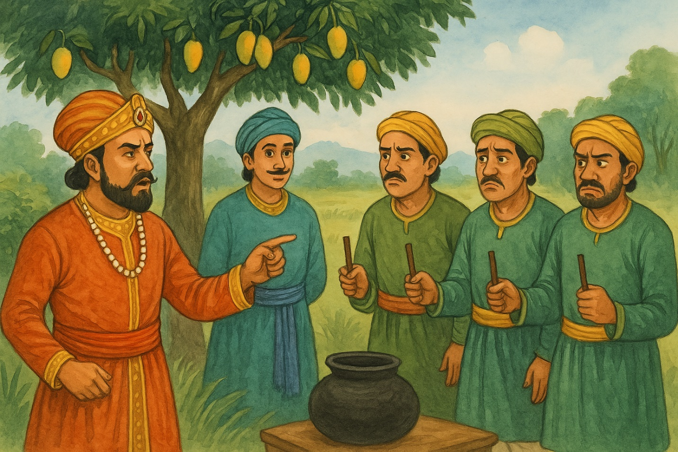

**https://notebooklm.google.com/notebook/fb026be5-c158-407c-82d8-7a591ecc7593/audio**

**Lesson Plan: Akbar and Birbal – The Missing Mangoes**

**Grade Level: 3–6  
Duration: 45–60 minutes  
Objective:  
Students will:**

* **Comprehend the narrative and moral of the Akbar-Birbal story.**
* **Develop critical thinking and inference skills.**
* **Express the story creatively through roleplay or drawing.**

**🧩 Materials Needed**

* **Printed version of the story / storytelling audio**
* **Whiteboard or chart paper**
* **Drawing paper and colors**
* **(Optional) Visual of the story (like the one created above)**

**🕰️ Lesson Breakdown**

**1. Introduction (5–10 minutes)**

* **Ask students: “Have you heard of Akbar and Birbal?”**
* **Briefly introduce Emperor Akbar and Birbal — focus on their witty and wise relationship.**

**2. Story Time (10–15 minutes)**

* **Read aloud or play an audio version of "The Missing Mangoes" story.**
* **Display the visual illustration.**
* **Ask simple comprehension questions:**
  + **What was stolen?**
  + **Who was suspicious?**
  + **What clever trick did Birbal use?**

**3. Discussion (10 minutes)**

* **What does this story teach us?**
* **Why did the guilty person cut their stick?**
* **How did Birbal know who the thief was?**

**Key Takeaway: Smart thinking and honesty always win!**

**4. Activity Options (Choose One – 15–20 minutes)**

**Option A: Role Play**

* **Assign students roles (Akbar, Birbal, Guards, Thief).**
* **Reenact the scene using simple props or costumes.**

**Option B: Draw the Scene**

* **Let students illustrate their favorite scene from the story.**

**Option C: Stick Trick Game**

* **Hand out "magic" sticks (pencils) and try a fun version of Birbal’s trick with harmless mischief!**

**5. Conclusion (5 minutes)**

* **Summarize the moral: Truth can’t be hidden. Cleverness with kindness is powerful.**
* **Ask: What would you have done if you were Birbal?**

**✏️ Assessment**

* **Informal: Participation in discussion or activity.**
* **Optional: Short written reflection: “What did I learn from Birbal**

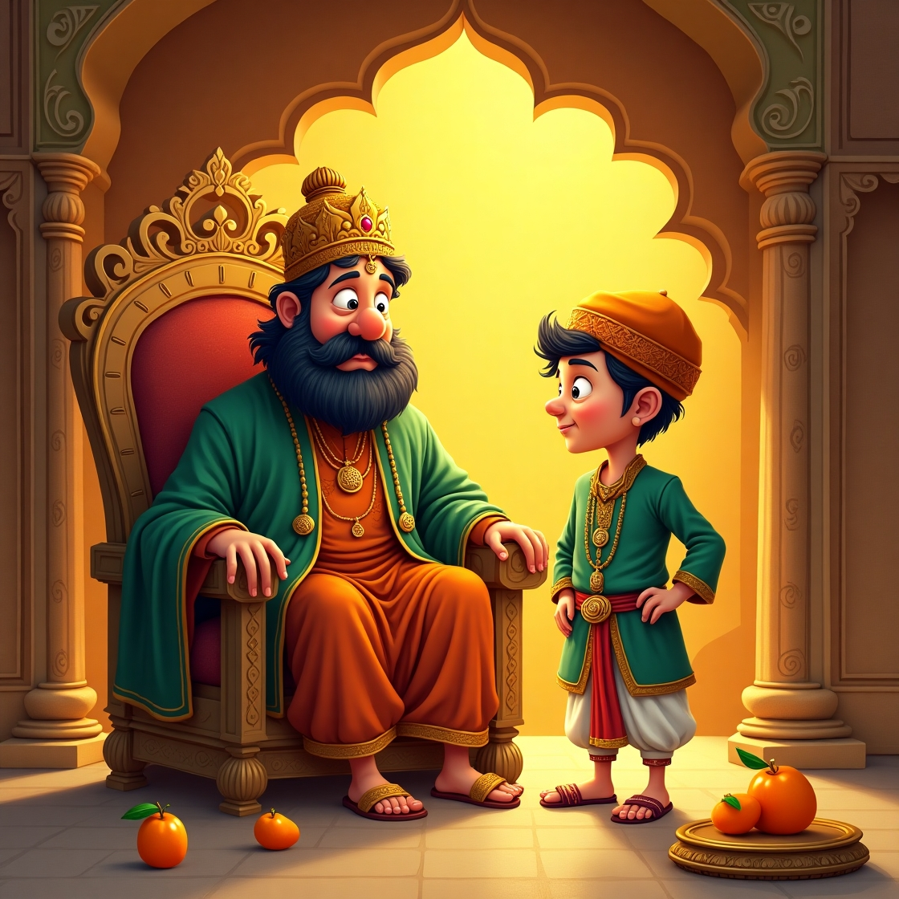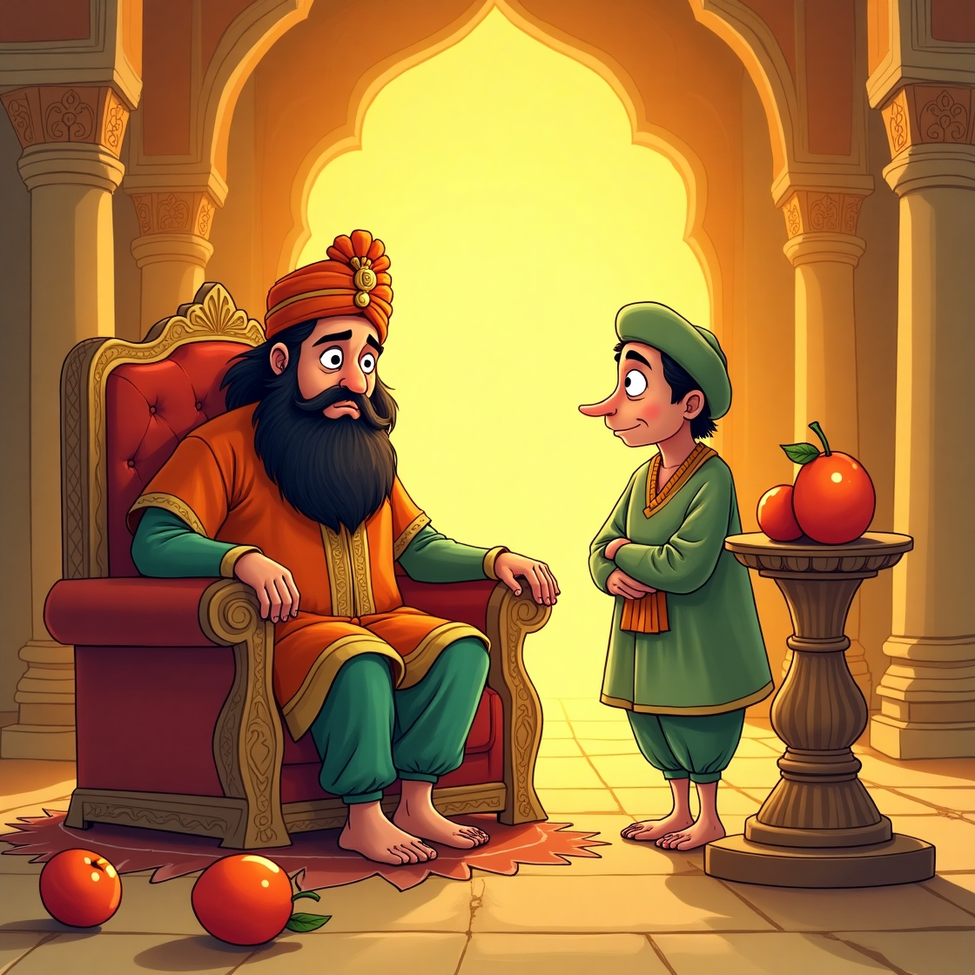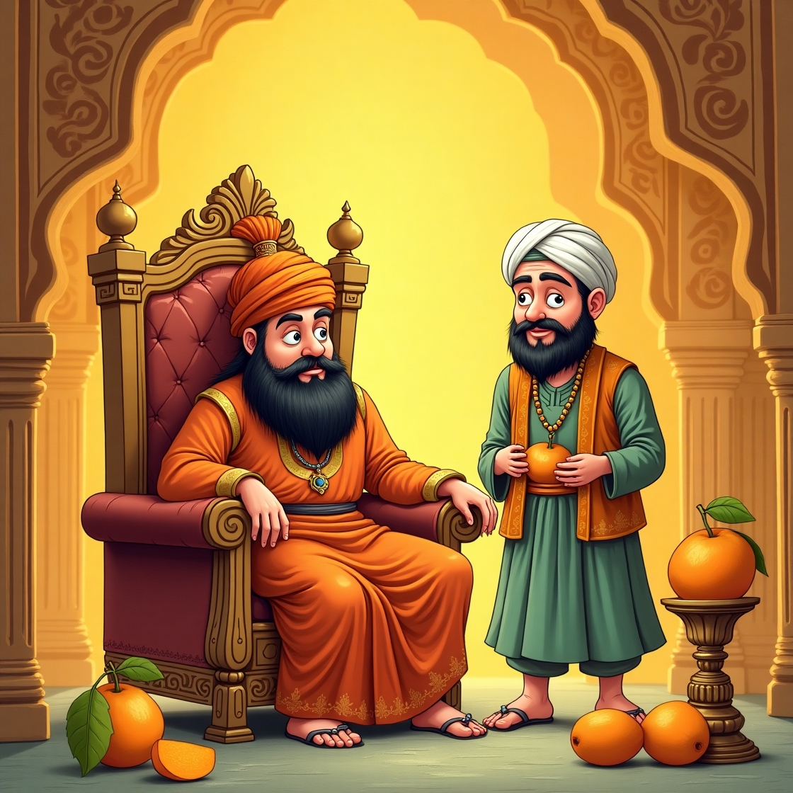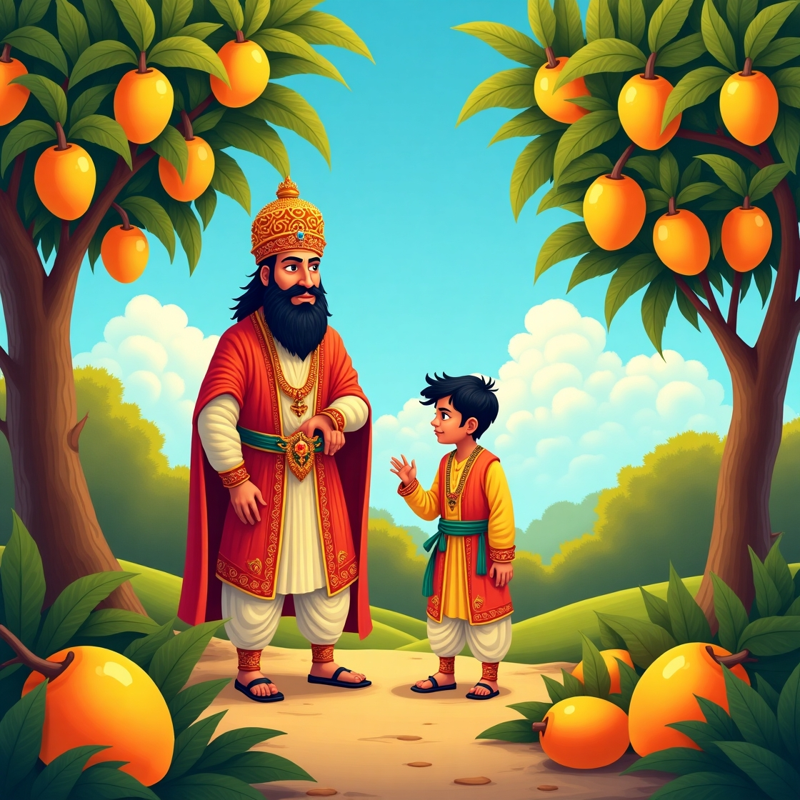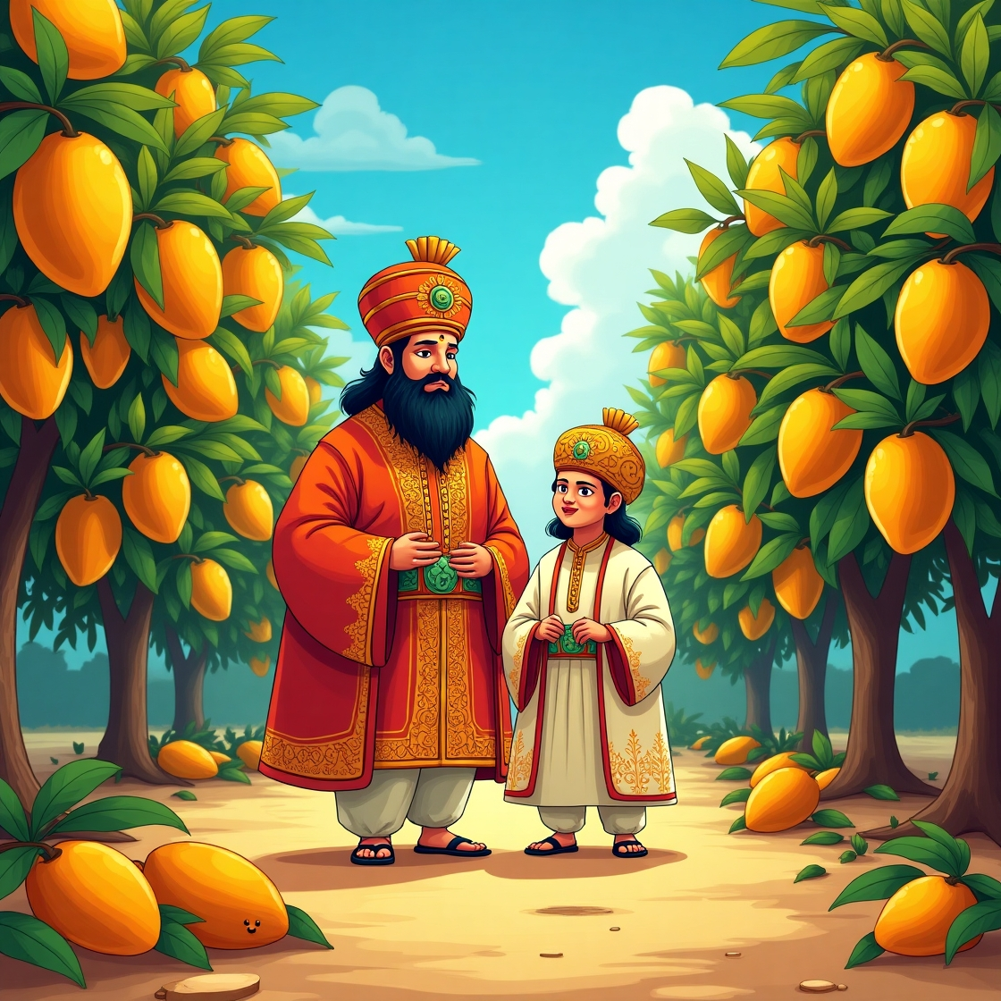

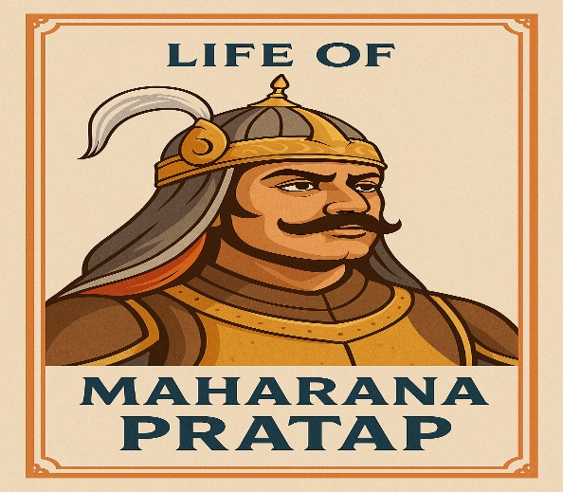**Lesson Plan: The Life of Maharana Pratap**

**Subject**: History  
**Grade Level**: 6–8  
**Topic**: Life of Maharana Pratap  
**Duration**: 45–60 minutes

**Audio link https://notebooklm.google.com/notebook/a1bc3d8b-02bb-4806-832f-83f8e13c1f03/audio**

**Learning Objectives:**

By the end of this lesson, students will be able to:

1. Describe the early life and background of Maharana Pratap.
2. Understand the significance of the Battle of Haldighati.
3. Recognize the values of bravery, patriotism, and resilience Maharana Pratap is known for.
4. Identify key events and figures associated with Maharana Pratap's life.

**Materials Needed:**

* Whiteboard and markers
* Projector/Smartboard
* PowerPoint Presentation or printed visuals
* Map of medieval India
* Worksheet with timeline and key events
* Short video clip on Maharana Pratap (if available)
* Chart paper and markers (for group activity)

**Lesson Structure:**

**1. Introduction (5–10 minutes)**

* Begin with a question: *"Who is a hero according to you?"*
* Show a picture of Maharana Pratap and ask if students recognize him.
* Briefly introduce him as a Rajput king known for his courage and defiance of the Mughal Empire.

**2. Presentation/Teaching (15–20 minutes)**

**Key points to cover:**

* **Birth and Early Life**:
  + Born in 1540 in Kumbhalgarh, Rajasthan.
  + Son of Maharana Udai Singh II of Mewar.
* **Mewar and the Mughals**:
  + Context of the Mughal expansion under Akbar.
  + Maharana Pratap’s refusal to submit to Mughal rule.
* **Battle of Haldighati (1576)**:
  + Fought against the Mughal army led by Man Singh I.
  + Though not a victory, it showed Rajput valor and resistance.
* **Later Life**:
  + Continued to fight guerrilla warfare.
  + Recovered much of Mewar except Chittorgarh.
* **Legacy**:
  + Remembered as a symbol of Rajput pride and freedom.
  + His horse Chetak is also a historical icon.

**3. Video/Visual Aid (5 minutes)**

* Show a 2–3 minute animated or documentary-style video clip highlighting the Battle of Haldighati or Maharana Pratap's life.
* http://youtube.com/watch?v=5Xp6KXpxCXw

**4. Group Activity (10–15 minutes)**

**Activity Idea**: Create a Timeline Poster

* Divide students into groups of 3–4.
* Provide key dates/events and ask students to illustrate them on chart paper with short descriptions.

**5. Class Discussion and Reflection (5–10 minutes)**

* Ask: *“What qualities of Maharana Pratap do you admire most?”*
* Encourage students to relate his bravery to real-life situations (e.g., standing up for what's right).

**6. Homework / Assessment:**

* Write a short paragraph: *“If I were Maharana Pratap…”*
* Worksheet with fill-in-the-blanks, match the following, and a short answer question.

**Assessment Criteria:**

* Participation in discussion and activity
* Accuracy in timeline/worksheet
* Thoughtfulness in homework reflection

**Battle of MAHARANA PRATAP SINGH**

The most well-known battle associated with Maharana Pratap is the Battle of Haldighati. Here's a breakdown of key information:

* **Battle of Haldighati:**
  + This battle took place on June 18, 1576.
  + It was fought between the forces of Maharana Pratap, the ruler of Mewar, and the Mughal army led by Raja Man Singh I of Amber.
  + The battle occurred at Haldighati, a mountain pass in the Aravalli Range near Gogunda, Rajasthan.
  + While the Mughal forces had a numerical advantage, Maharana Pratap's forces displayed immense valor.
  + The battle is remembered for Maharana Pratap's resistance against the Mughal Empire.
  + It is important to note that even though the Mughal forces gained a tactical victory, they did not capture Maharana Pratap.

Key aspects of Maharana Pratap's battles include:

* His unwavering resistance against Mughal Emperor Akbar's expansionist policies.
* His use of guerrilla warfare tactics, particularly in the hilly terrain of Mewar.
* His symbolization of Rajput valor and the fight for independence.

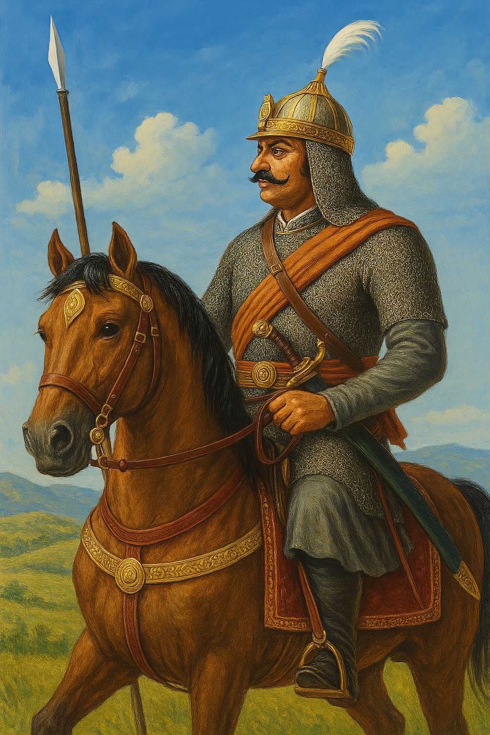

Great warrior **Maharana Pratap** with His horse **Chetak**